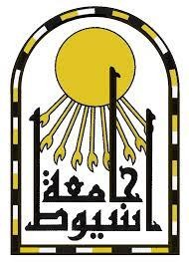  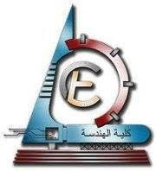

|  |  |  |
| --- | --- | --- |
| **Gehad mostafa kamel ahmed** |  |  |
| **Mining & Metallurgical Engineering Department Faculty of Engineering, University of Assiut**  **Assiut, Egypt.** | **Phone:** | **+20-1009464683**  **+20-1067746468** |
|  | **E-mail:** | [**gehad.mostafa@aun.edu.eg**](mailto:gehad.mostafa@aun.edu.eg) |
|  |  | [**gehad.mostafa1@yahoo.com**](mailto:gehad.mostafa1@yahoo.com) |
|  |  |  |

# PERSONAL INFORMATION:

* **Sex :** Female
* **Marital Status :** Married
* **Nationality :** Egyptian

# EDUCATION:

* **2010-2014:** Bachelor’s Degree in Mining & Metallurgical Engineering, Assiut University, Egypt.

**General grade unit:** Excellent with Honor's degree.

* **2012-2013:** Project in Mine Surveying for a month in the red sea area [Mine Surveying Project].

**A CAREER TRANSCRIPT:**

     **2020 to present:** Assistant Researcher and Lecturer, Faculty of Engineering, Assiut University, Egypt.

     **2014 - 2020:** Demonstrator (Teaching and researcher assistant) ,Faculty of Engineering, Assiut University, Egypt